R .V. COLLEGE OF ENGINEERING, BENGALURU- 560 059
(Autonomous Institution Affiliated to VTU, Belagavi)



TITLE: Automated Lighting
Assignment Report

Submitted by

Name: Praneeta Immadisetty, Settipalle Sahithi
Roll No. 1RV19CS117, 1RV19CS142
Section: K

Submitted to,
Name of teacher in-charge: Dr. Shuba S.
Designation: Assistant Professor
Department of Physics
R V College of Engineering, Bengaluru-59

CERTIFICATE

Certified that the Assignment topic “Automated Lighting(Modelling)” is carried out by Praneeta Immadisetty [1RV19CS117] and Settipalle Sahithi [1RV19CS142] who are bonafide students of R V College of Engineering, Bengaluru in partial fulfilment of the award of seminar/assignment marks for the II semester academic year 2019-20 in Engineering Physics Course. It is certified that all corrections/ suggestions indicated for the internal assessment have been incorporated in the report, and a soft copy is deposited in the department library. The seminar/assignment report has been approved as it satisfies the academic requirement in respect of the work prescribed by the institution for the said course.

Signature of the Staff-in-charge

Automated Lighting

Praneeta Immadisetty , Settipalle Sahithi

Affiliation( dept of Physics, RVCE)

Abstract
The project aims at saving energy by detecting the vehicle movement on highways and switching on the block of street light ahead of it and simultaneously switching off the trailing lights. The vitality of this technology arises as fossil fuels is being over consumed which makes it challenging to provide sufficient power in the next era as an effect of growing population. This method provides a sustainable solution in terms of environment, economy, and social needs. In current years, the street light control is automated by changing the resistance using the light-sensitive device. The reliability of this method is less. Though it reduces the man power, it does not conserve energy spent during night time. The aim of Automated lighting is to save energy, and to save cost.

Key words
Automated street lights, sensor, resistor, transistor, energy conservation, motion of vehicles

Introduction
In our country electricity is mostly produced through the depletion of conventional resources like fossil fuel and a small fraction through nuclear or solar energy which are expensive. So, a better way to prevent the resources from getting exhausted is by saving as much power as we can. According to some reports, about 20 to 40% of electricity in India is used by street lights. Generally, street lights are switched on for whole night and during the day, they are switched off. But during the night time, street lights are not necessary if there is no traffic.In the past few decades, there are small number of streets in a town and city, street lamps and management control is relatively simple, but as the country developed into a well-off society, and with urbanization, the number of streets in the town increased rapidly. So the control and management of street lights became a problem. At present, street lamps control most of the urban only by manual control, a control switch set in each of the street lamps, it is also called as the first generation of the original street light control, which is inefficient and a waste of manpower. A huge amount of electrical energy is wasted. In this conventional system, the street lights have group based control which means individual lights cannot be controlled. Due to some natural calamities like storm, if there is a breakage in wire, the entire system gets affected. Maintenance cost will be high in order to repair this system. Also they make use of sodium vapour lamp which is harmful. The low pressure sodium vapour lamp produces 33,000 lumens which consumes more amount of energy.

Literature survey
N.Subhalakshmi, Jayalakshmi.A,
Janani.N, Induveni.S, Dhivya Dharshini.P in their paper Automatic Street Lights Lightened By Piezoelectric Roads, published in International Journal of Innovative Research in Science, Engineering and Technology used the principle of piezoelectricity behind the crystals. They have used piezoelectric devices beneath the road to achieve energy conservation through street lights.
R. Abinaya,V. Varsha and Kaluvan Hariharan in their paper, an intelligent street light system based on piezoelectric sensor networks, published in Indian Journal of Science and Technology, have also employed similar ways for smart lighting but have also included advanced technologies as IoT and ZigBee.
Taking inspiration from such research works we have come up with a simpler circuit and a sensor model for automated street lighting.

Role of Physics in the topic
The sensor under discussion is sensitive to pressure (or force). Thus it works similar to that of a simple switch. When there is contact or a touch on the surface (the resistor, discussed in detail further below), it acts as a closed switch and allows current flow, and when contact is released it acts similar to the opened switch and hence there is no flow of current.

Experimental Setup
Sensor Development
The design of our sensor includes 2 BC-547 transistors (n-p-n type), a 10kohms resistor, a 1.5kohms resistor, a 680 ohms resistor, a 5mm LED and a 9V battery.
We wired the transistors together so the emitter of the first stage transistor is connected to the base of the second stage transistor. This transistor configuration is called the Darlington configuration (commonly called a Darlington pair) and is a compound structure of a particular design made by two bipolar transistors connected in such a way that the current amplified by the first transistor is amplified further by the second one. The emitter of the second stage transistor is connected to the negative of the power source (battery). A 10kohms resistor is connected to the base terminal of first stage transistor. Other connections are made as shown in the circuit diagram below.
The sensor works by sensing the pressure when applied on the surface of 10kohms resistor.
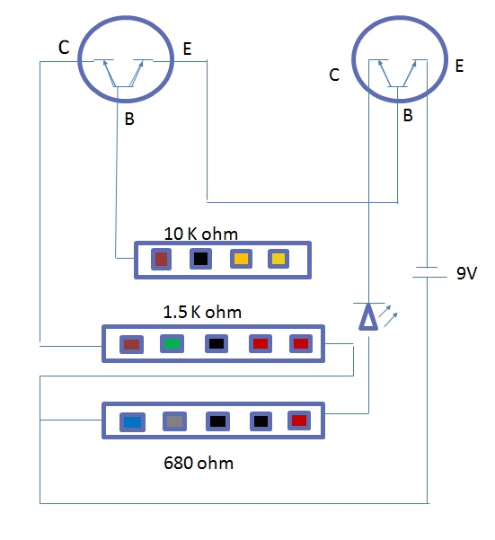
The sensor operates when an object touches the surface. Touch of the object forms a closed circuit which allows a small amount of current to flow. In the circuit the contact causes a very little current to flow.
The transistor amplifies the voltage to some significant value.
Resistance is used to protect the transistor from the high current. When pressure is applied on the top of the surface of resistor by the motion of vehicles on it, the circuit gets complete and the current gets amplified through the transistors.
As a result, the LED glows. The 680ohms resistor in series with the LED prevents its damage from amplified voltage.

Published data with table and graph
Below are 2 graphs given, Energy consumption v/s timing in a day, which illustrate the minimization of power usage by street lights on installation of sensors.
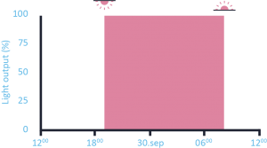
This graph is before having sensors and shows a constant power output at all times.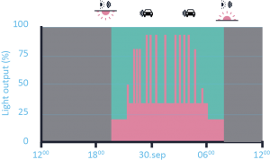
The above graph after the sensors shows lower power output in absence of heavy traffic. The above data supports the power conservation.

Inference/conclusions
We have millions of roads around the world and each day a very huge amount of energy is wasted because of the conventional street light system. Though at some modern places they have moved on to the other sensor controlled street lighting systems like IR, ultrasonic systems, they are too costly and ineffective to offer for the normal roads in other places. Since we make use of piezoelectric sensors, the above system is cost effective and has no major flaws. Thus, this method can be use deficiently in street light management to save power.
Acknowledgement
We would like to thank our Physics lecturer Dr. Shuba S. for giving us an opportunity in exploring new domains and expanding our potentials to the field of sensors. We also thank her for providing the necessary feedback and support for the completion the modelling project.
References
- Subhalakshmi, Jayalakshmi.A,
Janani.N, Induveni.S, Dhivya Dharshini.P, Automatic Street Lights Lightened By Piezoelectric Roads, published in International Journal of Innovative Research in Science, Engineering and Technology, Volume 6, Issue no. 14, 2017.
2. R. Abinaya,V. Varsha and Kaluvan Hariharan, an intelligent street light system based on piezoelectric sensor networks, Indian Journal of Science and Technology, Vol 9(43), November 2016.

